GAS LEAKAGE MONITORING AND

ALERTING

SYSTEM FOR INDUSTRIES

# **Domain: IOT**

**A PROJECT REPORT**

***Submitted by***

|  |  |
| --- | --- |
| **VAISHALI. S** | **(920819104050)** |
| **HIFAYA THAQFEEN. M** | **(920819104014)** |
| **NANDHINI. S** | **(920819104024)** |
| **SARANYA. R** | **(920819104032)** |

***in partial fulfilment for the award of the degree***

***of***

**BACHELOR OF ENGINEERING**

***in***

COMPUTER SCIENCE AND ENGINEERING

# **NPR COLLEGE OF ENGINEERING & TECHNOLOGY** **NATHAM, DINDIGUL**.

**ANNA UNIVERSITY: CHENNAI 600 025**

# 

# **TABLE OF CONTENTS**

**CHAPTER NO. TITLE PAGE NO.**

1. **INTRODUCTION 1**

1.1 Overview 1

2.2 Purpose 2

1. **LITERATURE SURVEY 3**

2.1 Existing problem 3

2.2 References 5

* 1. Problem Statement Definition 8

1. **IDEATION&PROPOSED SYSTEM 9**

3.1 Empathy Map Canvas 9

3.2 Ideation & Brainstorming 11

3.3 Proposed Solution 14

3.4 Proposed Solution Fit 15

1. **REQUIREMENT ANALYSIS 16**

4.1 Functional Requirement 16

* 1. Non-Functional Requirement 17

1. **PROJECT DESIGN 18**

5.1 Data Flow Diagram 18

5.2 Solution & Technical Architecture 19

* 1. User Stories 21

1. **PROJECT PLANNING & SCHEDULING 22**

6.1 Sprint Planning & Estimation 22

6.2 Sprint Delivery Schedule 23

* 1. Reports from JIRA

1. **CODING & SOLUTIONING 25**

7.1 Feature 1 25

* 1. Feature 2 27

1. **TESTING 32**

8.1 Test Cases 32

* 1. User Acceptance Testing 33

1. **RESULTS 35**
   1. Performance Metrices 35

1. **ADVANTAGES & DISADVANTAGES 36**

1. **CONLUSION 37**

1. **FUTURE SCOPE 38**

**13. APPENDIX 39**

Source code 39

GitHub & Project demo link

**CHAPTER 1**

**INTRODUCTION**

**1.1 PROJECT OVERVIEW**

Gas leakage poses great danger in this modern era where the use of gas has become an important source of energy for industries, homes and vehicles alike. The leakage of Liquefied Petroleum Gas (LPG) is known to cause serious accidents which have resulted in loss of lives and properties worth billions of dollars across the globe. The catastrophic explosions at Nyaniba Health Assistants Training School in Team, Valdo estate, UDS in WA, Ashaiman, Axim and Kwahu in the Eastern Region (Owusu, 2014) are but a few cases that have occurred over the last two years in Ghana. LPG is one of the most used fuels in Ghana and as such precautions have to be taken in order to safe guard against accidents such as explosions and suffocation that are associated with its usage. LPG is made up of mixtures of propane and butane which are in flammable chemicals. Due to the odourless nature of these chemicals, Ethyl Mercaptan is added as odorant in order to make the gas detectable by smell. However, some people have poor sense of smell especially at low concentrations and so a more effective and reliable means of detecting the gas has to be adopted in homes, industries and vehicles that rely on the use of LPG. One of the preventive methods of stopping accident associated with LPG leakage is to install gas leakage detection devices. Even though there have been great strides in developing effective LPG leakages detection and response systems over the past years, there are still improvements that can be made to previous designs. Most systems developed focus on the detection of the leakage and sounding of an alarm in response to the detection.

**1.2 PURPOSE**

The objectives of this project are:

* To design a system that monitors LPG leakage in an enclosed area (home, car or industry);
* To design a system that alarms the user of leakage; and
* To design a system that shuts down LPG supply during leakage.

The research methods adopted include:

* Review of related literature.
* Use of datasheet in selecting suitable components for the circuit design.
* Circuit design and simulation using Proteus; and
* Analysis of results from simulation

This work is limited to the design of an efficient system for monitoring LPG leakage in a susceptible area, alerting the user and shutting down the gas supply using a microcontroller-based detection system.

This work is organised into five chapters. The first chapter deals with the problem definition, project objectives, methods used, facilities used for the project and the scope of work. Chapter two gives the review of the related literature. Chapter three focuses on the proposed design and component selection for the Microcontroller based LPG leakage detection and response system. The fourth chapter provides a detailed analysis of results from simulation and the last chapter talks about conclusion and recommendations.

2

**CHAPTER 2**

**LITERATURE REVIEW**

**2.1 EXISTING PROBLEM**

Liquefied Petroleum Gas commonly known as LPG consists of a mixture of Commercial Propane and Commercial Butane having saturated as well as unsaturated hydrocarbons. It is an odourless gas due to which Ethyl Mercaptan is added as powerful odorant so that leakage can easily be detected. LPG is commonly used in homes for heating and cooking. This energy source is primarily composed of propane and butane which are highly flammable chemical compounds.

LPG was first produced in 1910 by Walter Snelling (Didpaye1, 2015) and is classified as a hazardous material because of its flammable properties and explosive potential when stored under pressure. Before the development of electronic household gas detectors in the1980s and 90s, gas presence was detected with alchemically infused paper that changed its colour when exposed to the gas (Didpaye1, 2015). Since then, many technologies and devices have been developed to detect, monitor, and alert the leakage of a wide array of gases. Hence the requirement of an efficient system to detect leakage of LPG is inevitable, which may be used for domestic and commercial purposes.

3

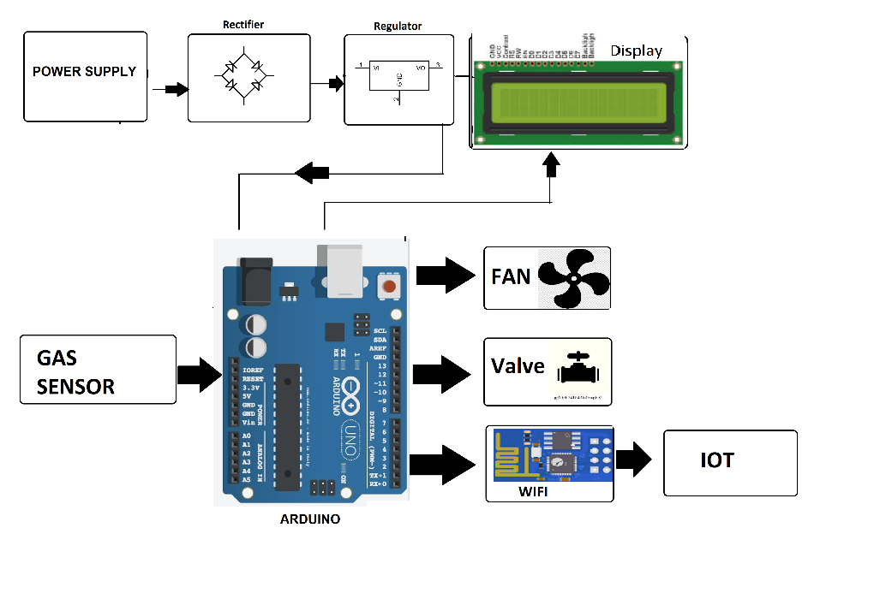

**Fig:2.1 Diagram of how the system works**

There are various classifications available for leakage detection. Severalcriteria are considered for classification, some of which are, the amount of human intervention needed, thephysical quantity measured and the technical nature of the methods (Murvaya, 2011).If the degree of intervention needed from a human, by each detection method is used for classification, three categories are used to distinguish between them (Murvaya, 2011):

* Automated detection – complete monitoring systems that, can report the detection of a gas leakwithout the need of a human operator, once they are installed (e.g., fibre optic or cable sensors);
* Semi-automated detection – solutions that need a certain amount of input or help in performingsome tasks (e.g., statistical or digital signal processing methods); and
* Manual detection – systems and devices that can only be directly operated by a person (e.g., thermalimagers or Light Detection and Ranging (LIDAR) devices).

4

**2.2 REFERENCES**

|  |  |  |  |
| --- | --- | --- | --- |
| **S.NO** | **TITLE** | **AUTHOR’S NAME** | **WORK** |
| 1 | Smart Gas Level Monitoring, Booking &Gas Leakage Detector over IoT | Kumar Keshamoni;Sabbani Hemanth. | They explain the gas cylinder monitoring system using IoT |
| 2 | Arduino Based LPG gas Monitoring & AutomaticCylinder booking withAlert System | R.Naresh Naik, P.Siva Nagendra Reddy,S.Nanda | make an automatic booking system of gascylinder when it come to an end. Alarm system for gas leakage. |
| 3 | LPG Monitoring and Leakage Detection System | Shruthi Mohammed Razil, Joshua Benny, Shelvin Varghese | They Monitor the LPGcylinderwith the leakageand alarm system. |
| 4 | A Security alertsystem using GSMfor Gas Leakage. | S.RAJITHA,T. SWAPNA | To monitor liquid petroleum gas (LPG)leakage to avoid fire accidents providing house safety feature to provide an alert by sendingSMS. |

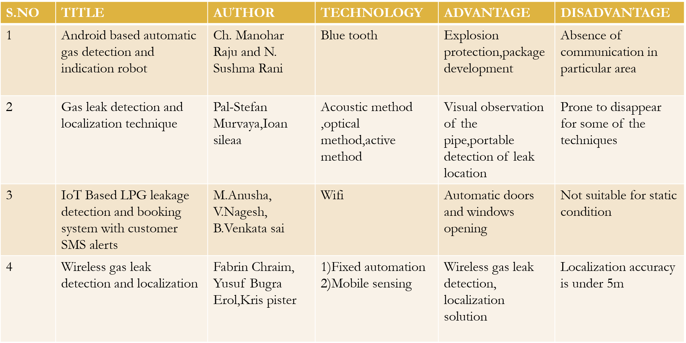

Most detection techniques rely on the measurement of a certain physical quantity or the manifestation of certain physical phenomenon. This can be used as a rule for classification as there are several commonly used physical parameters and phenomena namely; acoustics, flow rate, pressure, gas sampling, optics and sometimes a mix of these. Because of the great variety of these detection solutions, leak finding technologies are sometimes classified into optical and non-optical methods (Batzias *et al*., 2011).

Some authors see the technology as fitting into two great categories direct methods and indirect or inferential methods (Folga, 2007 and Liu *et al*., 2008). The direct detection is made by patrolling along the pipelines using either visual inspection or handheld devices for measuring gas emanations. Thanks to technological advancements it is now common to use helicopter or airplane-mounted optical imaging devices especially for very long pipelines (Liu *et al*., 2008). Indirect or inferential methods detect leaks by measuring the change of certain pipe parameters such as flow rate and pressure

6

The most common way of classifying leak detection methods is based on their technical nature (Scott Land, 2003). Thus, two main categories can be distinguished: hardware-based method sand software-based methods. These two categories are sometimes mentioned as externally or internally based leak detection systems. Fig. illustrates these main categories and the different methods associated with each of them. This classification is similar to the one presented in the previous paragraph with the remark that indirect or inferential methods overlap with the software-based methods while the direct methods cover both hardware methods and non-technical methods.

Non-technical leak detection methods are the ones that do not make use of any device and rely only on the natural senses (i.e., hearing, smelling, and seeing) of humans and/or animals.

Hardware based methods rely mainly on the usage of special sensing devices in the detection of gas leaks. Depending on the type of sensors and equipment used for detection, these hardware methods can be further classified as: acoustic, optical, cable sensor, soil monitoring, ultrasonic flow meters and vapour sampling.

Software based methods, as the name states, have software programs at their core. The implemented algorithms continuously monitor the state of pressure, temperature, flow rate or other pipeline parameter sand can infer, based on the evolution of these quantities, if a leak has occurred. The software methods can use different approaches to detect leaks: mass/volume balance, real time transient modelling, and acoustic/negative pressure wave, pressure point analysis, statistics or digital signal processing.

**7**

**2..3 PROBLEM STATEMENT DEFINITION**

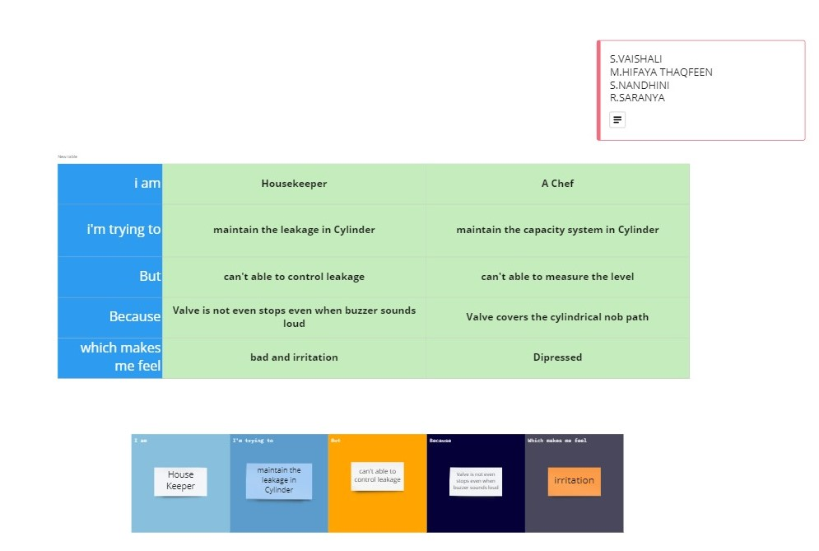

# **Problem Statement:**

* While a consumer notices the gas is leaking, He/she might get frightened about leakages due to the unexpected Valve opens or leaks that include holes in the cylinder tube, valve is not fitted in properly, etc.
* To avoid these kinds of issues and to maintain the leakages, there should be a Gas sensor sense the condition and intimate to the users directly through mobiles and alerting a light in device and to inform the consumer to alert the level of leakages in cylinder.

8

**CHAPTER 3**

**IDEATION & PROPOSED SOLUTION**

# **3.1 Empathy Map Canvas:**

An **empathy map** is a collaborative visualization used to articulate what we know about a particular type of user. It externalizes knowledge about users in order to

* + 1. create a shared understanding of user needs, and
    2. aid in decision making.

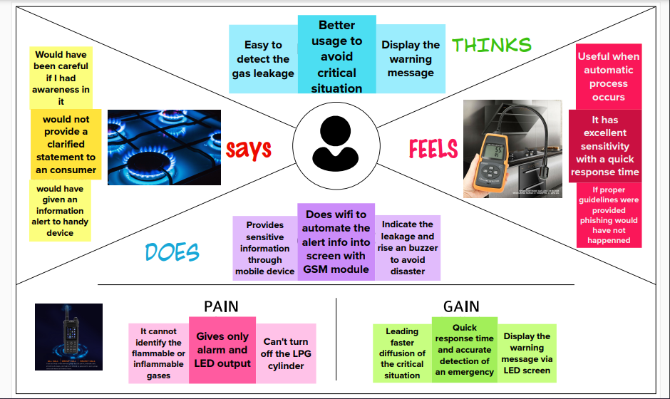

# **Explanation:**

**What do they think and feel?**

* Easy to detect the gas leakage
* Useful when the automation process occurs

9

* Display the alert message in mobile and LED screen.

# **What do they see?:**

* Gas sensor to sense the leakage in cylinder
* Dynamically sends the warning messages.

# **What do they say and do?:**

* Control the leakage and close the valve
* Often used for all homes and hotels.
* Can avoid unwanted leakages in solenoid valve.

# **What do they hear?:**

* This might be an enhancing technology in the future of Transportation Engineering
* Smart Gas monitoring will be indispensable part of Smart kitchens.

10

# **Ideation and Brainstorming**

Brainstorming provides a free and open environment that encourages everyone within a team to participate in the creative thinking process that leads to problem solving. Prioritizing volume over value, out-of-the-box ideas are welcome and built upon, and all participants are encouraged to collaborate, helping each other develop a rich amount of creative solutions.

# **Step-1: Team Gathering, Collaboration and Select the Problem Statement**

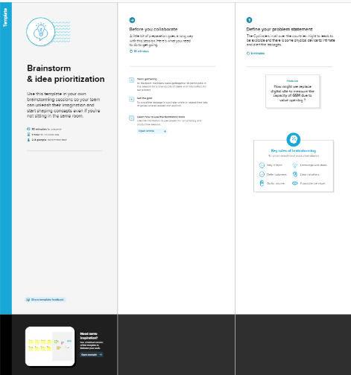

11

**Step-2: Brainstorm, Idea Listing and Grouping:**

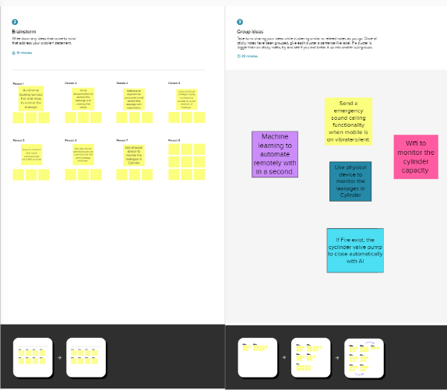

12

# **Step-3: Idea Prioritization:**

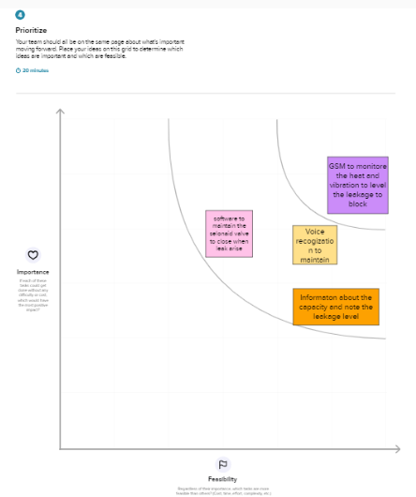

13

# **Proposed System:**

|  |  |  |
| --- | --- | --- |
| **S.No.** | **Parameter** | **Description** |
| 1 | Problem Statement | Develop an efficient system & an application that can monitor and alert the users(workers) |
| 2 | Idea / Solution description | This product helps the industries in monitoring the emission of harmful gases In several areas, the gas sensors will be integrated to monitor the gas leakage .If in any area gas leakage is detected the admins will be notified along with the location In the web application, admins can view the sensor parameters. |
| 3 | Novelty / Uniqueness | Fastest alerts to the workers User friendly |
| 4 | Social Impact / Customer Satisfaction | Cost efficient Easy installation and provide efficient results Can work with irrespective of fear |
| 5 | Business Model (Revenue Model) | The product is advertised all over the platforms. Since it is economical, it even helps small scale industries from disasters. As the product usage can be understood by everyone, it is easy for them to use it properly for their safest organization. |
| 6 | Scalability of the Solution | Since the product is cost-efficient, it can be placed in many places in the industry. Even when the gas leakage is more, the product senses the accurate values and alerts the workers effectively. |

14

# **3.4 Proposed System fit:**

15

**CHAPTER 4**

**REQUIREMENT ANALYSIS**

# **FUNCTIONAL REQUIREMENT:**

Functional requirements may involve calculations, technical details, data manipulation and processing, and other specific functionality that define what a system is supposed to accomplish. Behavioral requirements describe all the cases where the system uses the functional requirements, these are captured in use cases.

Following are the functional requirements of the proposed solution.

|  |  |  |
| --- | --- | --- |
| **FR No.** | **Functional Requirement (Epic)** | **Sub Requirement (Story / Sub-Task)** |
| FR-1 | User Registration | Registration through the Arduino code view. |
| FR-2 | User Confirmation | Confirmation via Message for alerting. |
| FR-3 | User verification | The user shall be able to receive warning message as quickly as possible. |
| FR-4 | Sensors:   * GSM Sensor * Relay * Wifi module | These 3 sensors are used to intimate the leakage condition as unproper valve, alert messages etc., |
| FR-5 | MQTT Protocol | To connect the cloud storage and Users Device |
| FR-6 | User Convenience | Through messages we can easily get data of gas level and in case of gas leakage, it can directly send notifications to nearby police stations and hospitals. |
| FR-7 | User Performance | When the user gets notified, he could turn on the exhaust fan/sprinkler. |

16

# **NON-FUNCTIONAL REQUIREMENT:**

Non-Functional Requirements are the constraints or the requirements imposed on the system. They specify the quality attribute of the software. Non-Functional Requirements deal with issues like scalability, maintainability, performance, portability, security, reliability, and many more.

Following are the non-functional requirements of the proposed solution.

|  |  |  |
| --- | --- | --- |
| **FR No.** | **Non-Functional Requirement** | **Description** |
| NFR-1 | **Usability** | The system interface should be easy and effective. (User-friendly) |
| NFR-2 | **Security** | The communication between the Arduino and the GLDS should be secure by encryption. |
| NFR-3 | **Reliability** | It is reliable since all the sensors will sense the same thing and intimate the messages |
| NFR-4 | **Performance** | The system should response immediately to any leakage situation. |
| NFR-5 | **Availability** | The system should work 24 hours 7 days a week. |
| NFR-6 | **Scalability** | The system should be operated in machine coding in Arduino |

17

**CHAPTER 5**

**PROJECT DESIGN**

**5.1 DATA FLOW DIAGRAM:**

A Data Flow Diagram (DFD) is a traditional visual representation of the information flows within a system. A neat and clear DFD can depict the right amount of the system requirement graphically. It shows how data enters and leaves the system, what changes the information, and where data is stored.

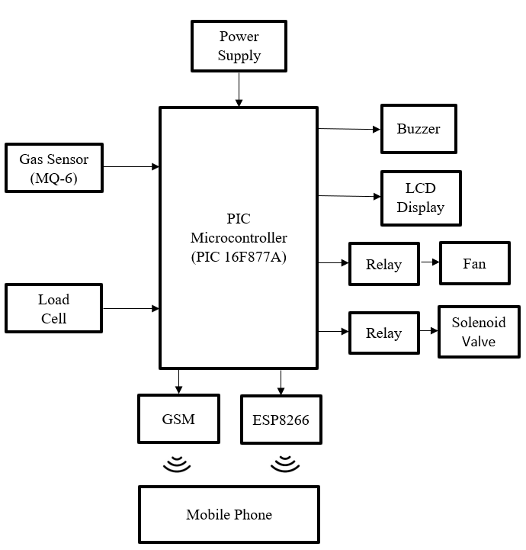

18

**5.2 SOLUTION AND TECHNOLOGY ARCHITECTURE:**

**5.2.1 SOLUTION ARCHITECTURE:**

Solution architecture is a complex process – with many sub-processes – that bridges the gap between business problems and technology solutions. Its goals are to:

* Find the best tech solution to solve existing business problems.
* Describe the structure, characteristics, behavior, and other aspects of the software to project stakeholders.
* Define features, development phases, and solution requirements.
* Provide specification according to which the solution is defined, managed and delivered.

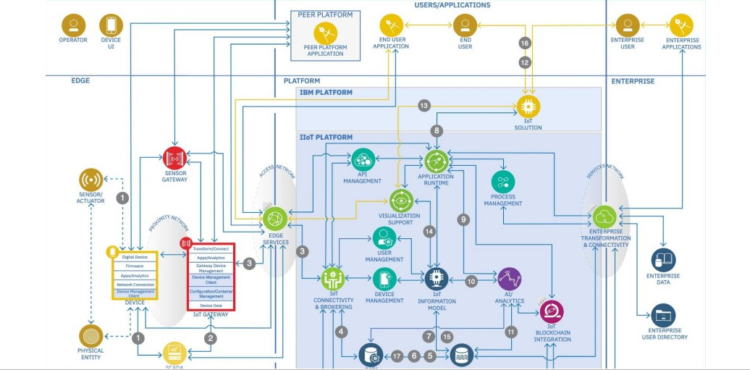

19

**5.2.2 TECHNOLOGY ARCHITECTURE:**

Technology architecture deals with the deployment of application components on technology components. A standard set of predefined technology components is provided in order to represent servers, network, workstations, and so on.



**5.3 USER STORIES:**

|  |  |  |  |  |
| --- | --- | --- | --- | --- |
| **Release** | **Functional Requirement (Epic)** | **User Story Number** | **User Story / Task** | **Priority** |
| Sprint-1 | Analyzing the gas leakage | USN-1 | The owner who wants to save his employees or a person who wants to save their family from explosion takes necessary actions | High |
| Sprint-1 | Preventing from explosion | USN-2 | The fire officers worries about any explosions due to gas leakage which may cause many death | High |
| Sprint-2 | To detect the gas leakage | USN-3 | The owner can take necessary steps by deploying gas detectors in their surroundings | Medium |
| Sprint-3 | Testing and training of the model device | USN-4 | The programmer can design an gas leakage detection model by training the dataset | Medium |
| Sprint-4 | Notification | USN-5 | The gas leakage detected by the model can be notified using SMS or alarming system | High |

21

**CHAPTER 6**

# **PROJECT PLANNING AND SCHEDULING**

**6.1 SPRINT PLANNING AND ESTIMATION**

|  |  |  |  |  |  |  |
| --- | --- | --- | --- | --- | --- | --- |
| **Sprint** | **Functional Requirement (Epic)** | **User Story Number** | **User Story / Task** | **Story Points** | **Priority** | **Team Members** |
| Sprint-1 | Analyzing the gas leakage | USN-1 | The owner who wants to save his employees or a person who wants to save their family from explosion takes necessary actions | 2 | High | Nandhini S  Hifaya  Thaqfeen M  Saranya R |
| Sprint-1 | Preventing from explosion | USN-2 | The fire officers worries about any explosions due to gas leakage which may cause many death | 1 | High | Vaishali S  Nandhini S |
| Sprint-2 | To detect the gas leakage | USN-3 | The owner can take necessary steps by deploying gas detectors in their surroundings | 2 | Medium | Hifaya  Thaqfeen M  Nandhini S  Saranya R |
| Sprint-3 | Testing and training of the model device | USN-4 | The programmer can design an gas leakage detection model by training the dataset | 2 | Medium | Nandhini S  Hifaya  Thaqfeen M  Saranya R  Vaishali S |
| Sprint-4 | Notification | USN-5 | The gas leakage detected by the model can be notified using SMS or alarming system | 1 | High | Saranya R  Vaishali S |

# **SPRINT DELIVERY SCHEDULE:**

|  |  |  |  |  |  |  |
| --- | --- | --- | --- | --- | --- | --- |
| **Sprint** | **Total Story Points** | **Duration** | **Sprint Start Date** | **Sprint End Date (Planned)** | **Story Points Completed (as on Planned**  **End Date)** | **Sprint Release Date (Actual)** |
| Sprint-1 | 20 | 6 Days | 26 Oct 2022 | 30 Oct 2022 | 20 | 30 Oct 2022 |
| Sprint-2 | 20 | 6 Days | 1 Oct 2022 | 04 Nov 2022 | 20 | 04 Nov 2022 |
| Sprint-3 | 20 | 6 Days | 06 Nov 2022 | 10 Nov 2022 | 20 | 10 Nov 2022 |
| Sprint-4 | 20 | 6 Days | 13 Nov 2022 | 16 Nov 2022 | 20 | 16 Nov 2022 |

**Velocity:**

Imagine we have a 10-day sprint duration, and the velocity of the team is 20 (points per sprint). Let’s calculate the team’s average velocity (AV) per iteration unit (story points per day)

23

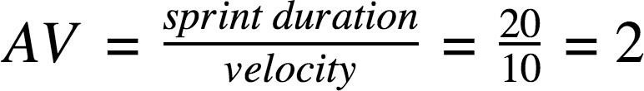

# **Burndown Chart:**

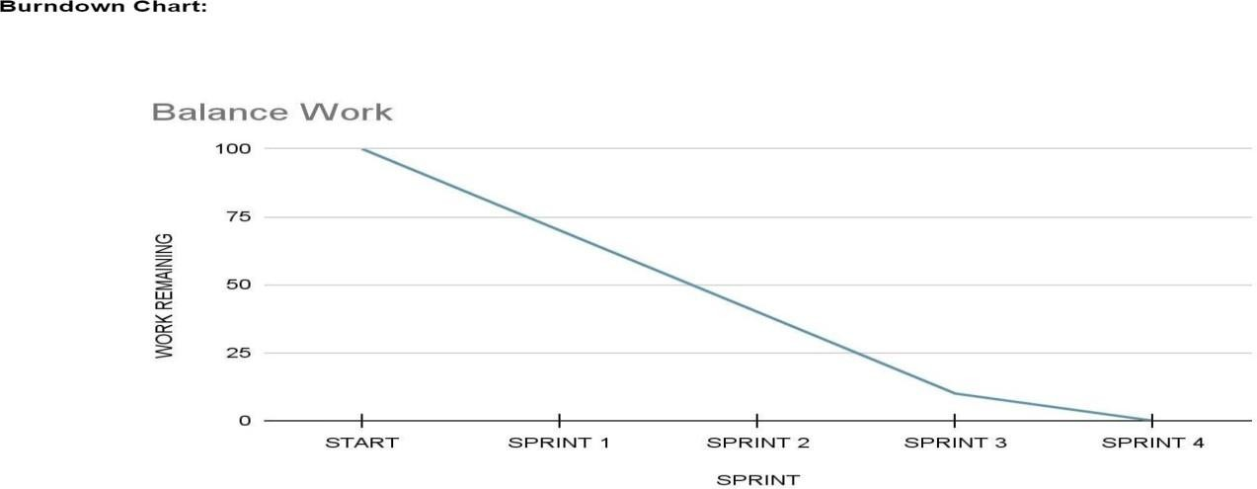A burn down chart is a graphical representation of work left to do versus time. It is often used in agile [software development](https://www.visual-paradigm.com/scrum/what-is-agile-software-development/) methodologies such as [Scrum](https://www.visual-paradigm.com/scrum/scrum-in-3-minutes/). However, burn down charts can be applied to any project containing measurable progress over time.

24

**CHAPTER 7**

**CODING AND SOLUTIONING**

**7.1 FEATURE 1**

**7.1.1 Creating IBM Watson device and getting simulation:**

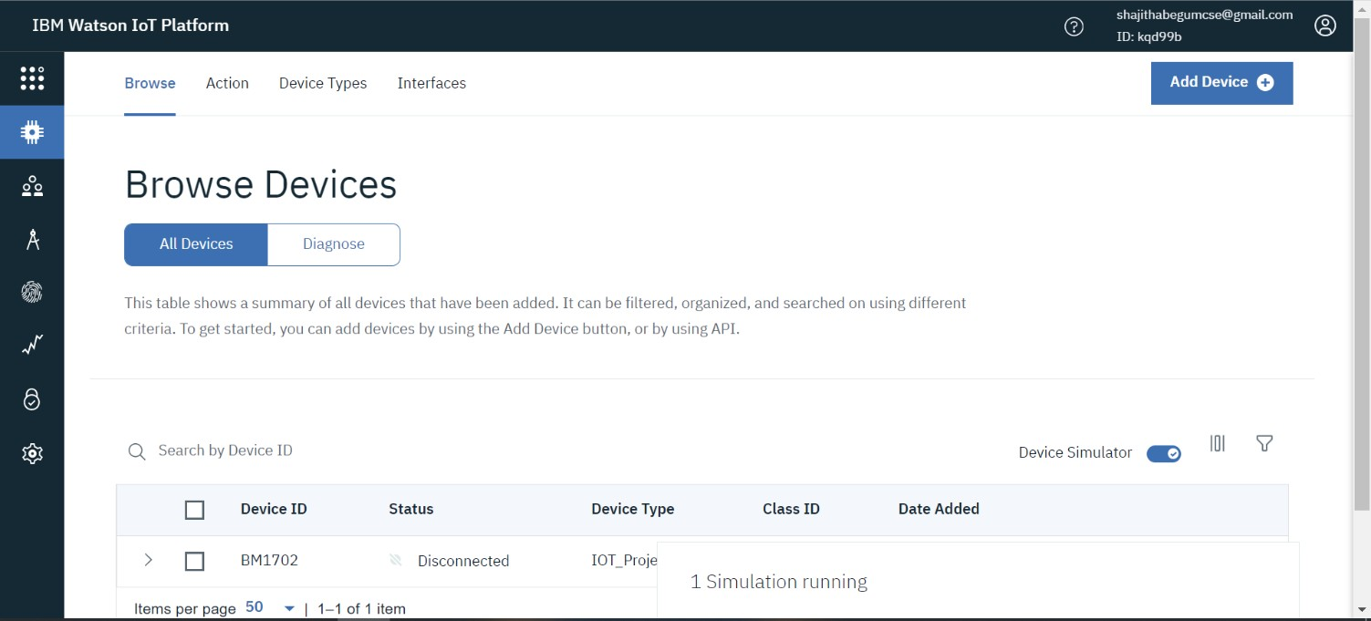 The IBM Watson Device is created and it was coded with JSON language to get the simulation.

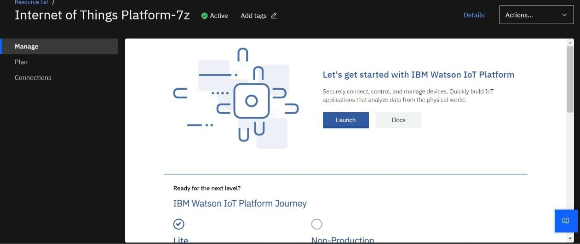

25

**7.1.2 Creating NODE-RED Service that displays the simulation:**

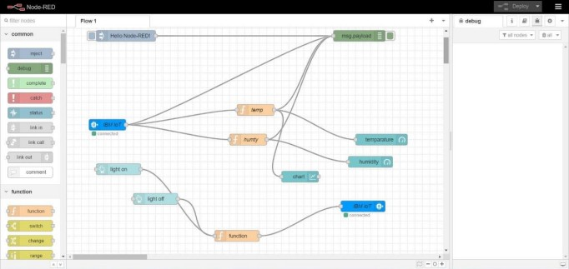

**7.1.3 Web UI design:**

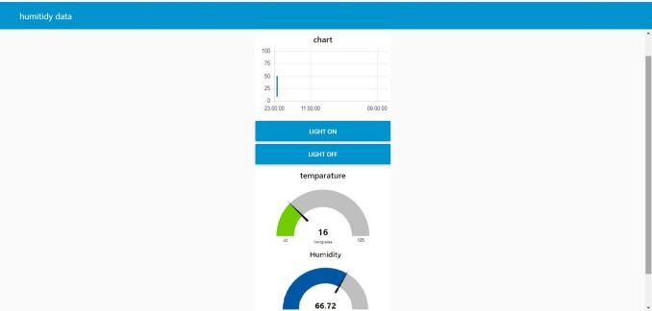

**7.2 FEATURE 2**

**7.2.1 CODING**

#include <LiquidCrystal.h>

const int rs = 2, en = 3, d4 = 4, d5 = 5, d6 = 6, d7 = 7;

LiquidCrystal lcd(rs, en, d4, d5, d6, d7);

int buzzer = 8;

int relay = 9;

int g =0;

void setup()

{

lcd.begin(16, 2);

lcd.clear();

lcd.setCursor(0, 0);

lcd.print(" AUTOMATIC GAS");

lcd.setCursor(0, 1);

lcd.print("LEKAGE DETECTION");

delay(1000);

pinMode(buzzer, OUTPUT);

27

pinMode(relay, OUTPUT);

pinMode(g, INPUT);

Serial.begin(9600);

Serial.println("AT");

delay(500);

Serial.println("AT+CMGF=1");

delay(500);

Serial.print("AT+CMGS=");

Serial.print("\"");

Serial.print("9842108409");

Serial.println("\"");

delay(500);

Serial.print("welcome");

delay(500);

Serial.println((char)26); // End AT command with a ^Z, ASCII code 26

delay(1000);

}

void loop()

28

{

float g = analogRead(A0); // gas

g=5*(g/1023);

g=g*10;

delay(100);

lcd.clear();

lcd.setCursor(0,0);

lcd.print("GAS LEVEL:");

lcd.setCursor(10,0);

lcd.print(g);

delay(1000);

if(g>20)

{

lcd.clear();

lcd.setCursor(0,0);

lcd.print("gas level high");

delay(1000);

29

digitalWrite(9, HIGH);

digitalWrite(8, LOW);

Serial.println("AT");

delay(500);

Serial.println("AT+CMGF=1");

delay(500);

Serial.print("AT+CMGS=");

Serial.print("\"");

Serial.print("9842108409");

Serial.println("\"");

delay(500);

Serial.print("gas level high");

delay(500);

Serial.print(g);

delay(500); // End AT command with a ^Z, ASCII code 26

delay(1000);

}

else

{

digitalWrite(9, LOW);

digitalWrite(8, HIGH);

delay(1000);

}}

30

**7.2.2 OUTPUT IN MOBILE DEVICE:**

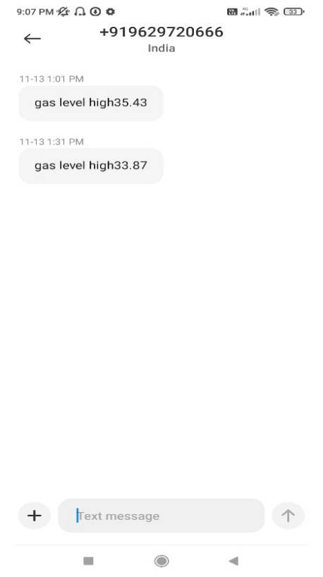

31

# **CHAPTER 8**

**TESTING**

**TEST CASE-1:**



**1.Simulation diagram of system under normal Conditions**

32

**TEST CASE-2**

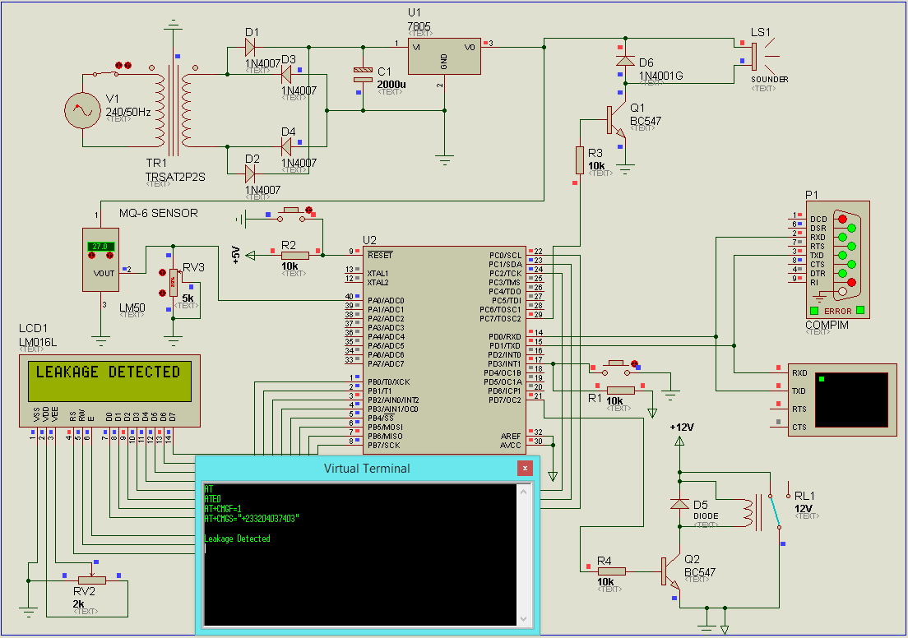

**2.Simulation diagram of system when leakage is detected**

**8.1 USER ACCEPTANCE TESTING**

Fig. 1 and Fig. 2 show the operation of the proposed design under normal conditions and when leakage is detected by the MQ-6 sensor respectively. During normal operations the Microcontroller displays “Monitoring LPG leakage” on an LCD screen. When leakage is detected, signal is sent to the buzzer to blow an alarm. A message which reads “Leakage Detected” is sent to the user’s phone through a GSM module. The same message is displaced on the LCD. Supply from the LPG mains is then shut off to stop further leakage.

33

The Compim in Fig. 2 represents the SIM900A GSM module through which

the leakage message is sent to the user phone. The Virtual Terminal beneath the Compim displays the programing codes and user phone number to which the “Leakage Detected” message is sent from the GSM module (Compim). The C language used in programming the microcontroller is shown in Appendix .

**Simulated Results of Output Power Supply**

It shows the analogue analysis of the output voltage of the power supply unit. The yellow line in the graph represents 12 V dc voltage which has been filtered by a shunt capacitor. The voltage is then regulated by a positive 5 V, 1 A regulator to give an output of 5 V which is represented in the graph by the red line. The 12 V is fed to the gas solenoid valve while the 5 V is fed to the MQ-6, Microcontroller and the Buzzer.

34

# **CHAPTER 9**

# **9.1 PERFORMANCE METRICS**

|  |  |  |
| --- | --- | --- |
| **PARAMETERS** | **IOT HARWARE** | **MOBILE ALERT** |
| **INFORMATION PASSING** | Information can be passed to the users in a slow manner. | Information can be passed to the users in a quick manner. |
| **VISIBILITY** | can lost its visibility due to unreadable sim connection | not lost its visibility as long as there is a problem in user’s device |
| **AVAILIBILITY** | Cannot maintain the range of the gas. | Signals can be sent to the user’s mobile phone itself. |
| **LEAKAGE PREVENTION** | can close the valve by itself when the leakage arises in GSM module. | It will shows the leakage alert notification to a uploaded mobile phone. |

35

**CHAPTER 10**

**ADVANTAGES AND DISADVANTAGES**

**ADVANTAGES:**

* Quick response time and accurate detection of an emergency.
* Area monitored continuously.
* Display the warning message via smartphones.
* Leading faster diffusion of the critical situation.

**DISADVANTAGES:**

* Existing system gives only alarm and LED output.
* Can’t turn off the LPG cylinder.
* It cannot identify the flammable or inflammable gases.

36

**CHAPTER 11**

**CONCLUSION**

This work sets out the problem of LPG leakages that have resulted in numerous fatal casualties as well as damages to properties worth billions of dollars. As such a device that is capable of detecting such leakage sand shutting off the gas supply was designed and simulated successfully with the aid of Proteus.

The device is able to sense the leakage of LPG through a highly sensitive MQ-6 gas sensor and with the aid of a microcontroller activate a buzzer which buzzes to alert anyone nearby of leakage. An SMS with information “LPG Leakage Detected” is sent from the SIM900A GSM Module as a backup to alert the appropriate authority of leakage. Also, supply is shut down by the solenoid value unit under one minute to avoid wastage and possible accident.

37

**CHAPTER 12**

**FUTURE SCOPE**

Based on the design, the following are recommend:

* In the future implementation we are going to provide voice implementation that will guide the user by audible sounds. Further it can be provided with emergency alerts in which we can send messages to the close ones . For this function GPS tracking should be implemented in this plug-in device.
* This design should be taken up, funded and implemented by any individual who has an interest in the project, as it has a great potential of mitigating against accidents associated LPG leakage; and
* A weighing scale be incorporated into the design to measure the amount of gas used or left in the gas tank or cylinder.

38

**APPENDIX**

**ATMEGA32 PROGRAMMING CODES**

#include <LiquidCrystal.h>

const int rs = 2, en = 3, d4 = 4, d5 = 5, d6 = 6, d7 = 7;

LiquidCrystal lcd(rs, en, d4, d5, d6, d7);

int buzzer = 8;

int relay = 9;

int g =0;

void setup()

{

lcd.begin(16, 2);

lcd.clear();

lcd.setCursor(0, 0);

lcd.print(" AUTOMATIC GAS");

lcd.setCursor(0, 1);

lcd.print("LEKAGE DETECTION");

delay(1000);

pinMode(buzzer, OUTPUT);

pinMode(relay, OUTPUT);

pinMode(g, INPUT);

Serial.begin(9600);

Serial.println("AT");

delay(500);

Serial.println("AT+CMGF=1");

delay(500);

Serial.print("AT+CMGS=");

Serial.print("\"");

Serial.print("9842108409");

Serial.println("\"");

delay(500);

Serial.print("welcome");

delay(500);

Serial.println((char)26); // End AT command with a ^Z, ASCII code 26

39

delay(1000);

}

void loop()

{

float g = analogRead(A0); // gas

g=5*(g/1023);

g=g*10;

delay(100);

lcd.clear();

lcd.setCursor(0,0);

lcd.print("GAS LEVEL:");

lcd.setCursor(10,0);

lcd.print(g);

delay(1000);

if(g>20)

{

lcd.clear();

lcd.setCursor(0,0);

lcd.print("gas level high");

delay(1000);

digitalWrite(9, HIGH);

digitalWrite(8, LOW);

Serial.println("AT");

delay(500);

Serial.println("AT+CMGF=1");

delay(500);

Serial.print("AT+CMGS=");

Serial.print("\"");

Serial.print("9842108409");

Serial.println("\"");

delay(500);

Serial.print("gas level high");

delay(500);

Serial.print(g);

40

delay(500); // End AT command with a ^Z, ASCII code 26

delay(1000);

}

else

{

digitalWrite(9, LOW);

digitalWrite(8, HIGH);

delay(1000);

}

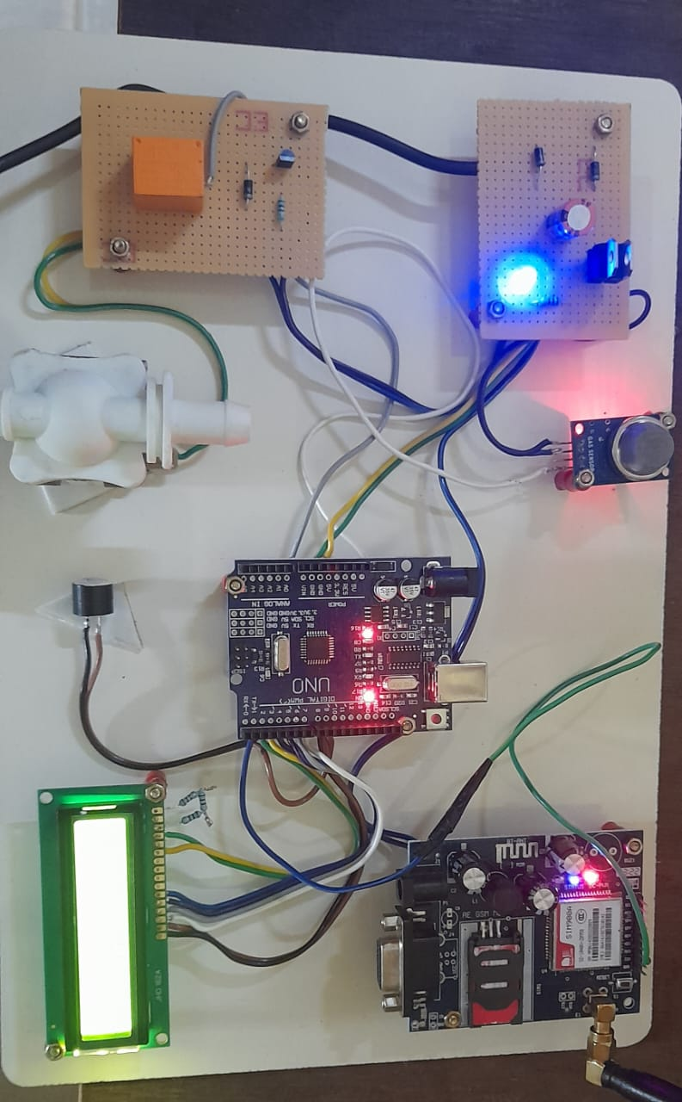}

**Photos:**

**PROJECT DEMO LINK:**

<https://drive.google.com/file/d/1fwbyrswfJx0SNgObH5uD5rHBvbZyEGsA/view?usp=drivesdk>

41